Book 04 — Federal Application-Aware Networking — HRIT and the Identity & Organizational SSOT
  - The Human System of Record · HR-Driven Account Lifecycle · Joiner-Mover-Leaver as Events · The Org Chart as an API
Federal Cloud Services
2026-07-06
Table of contents

INTERNAL — NOT FOR PUBLIC DISTRIBUTION
 Important
Series Context — This document is Part 4 of the 19-part Federal Application-Aware Networking series, and the last of the four substrate parts. Book 01 established the naming and addressing plane — what things are called and where they live. Book 02 established device identity at the port. Book 03 established cryptographic identity — certificates and tokens as the path-independent carriers of every identity claim. This part establishes what none of them can: the truth those claims assert. A token proves that an assertion was signed; it cannot prove the assertion describes a real, current employee with a real, current role. That fact originates in exactly one place — the human capital system of record — and this book makes it the authoritative source for the identity and organizational attributes every later part consumes. The modernization tracks of Parts 5 onward depend on this substrate; in particular, the identity-modernization program of Part 5 executes Principle 1 (single source of truth) against the directory estate, and Part 3’s tokens assert what this book makes true.

For decision makers: read this page first.
Your agency has spent three books building an identity architecture that can prove, cryptographically and at every hop, that a claim was made by the party authorized to make it. None of those three books can tell you whether the claim is true — whether the person behind the credential still works for the agency, still holds the position the access was granted for, still reports to the supervisor who approved it. That truth is not a network fact, a certificate fact, or a directory fact. It is an employment fact, and it lives in exactly one system: the human capital system of record.
Four things this document establishes:
- Parts 1–3 built the courier; this part writes the letter. Book 00 states the structural dependency: Principle 3 (token-based identity) depends on Principle 1 (single source of truth). Tokens work only if the authorization they assert is correct. Replacing session-based authentication while authorization remains encoded in twelve regional OU trees means signing broken authorizations efficiently. This book is the source of truth that dependency requires.
- Account lifecycle is an HR event stream, not a ticket queue. Hire, transfer, and separation are recorded as business events in the HR system before any administrator hears about them. An event-driven provisioning feed makes account creation, access re-derivation, and same-day revocation consequences of those records. A ticket queue makes them rumors of those records — days late, sometimes never.
- The org chart must stop being a drawing and become an API. Supervisory hierarchy, positions, and cost centers exist today as OU paths, Visio diagrams, and spreadsheets — none of which a policy engine can query. When organizational structure is a governed, queryable record, group membership is computed from attributes, access packages route approvals to the supervisor of record, and a reorganization is a data change instead of a migration project.
- A SaaS system of record integrates entirely through truth-plane surfaces. The deployed human capital platform — Oracle HCM Cloud, in the externally managed tenancy Book 01 placed as the fourth landing-zone environment — touches the enterprise through federation (SAML/OIDC), provisioning protocol (SCIM 2.0), DNS resolution, and evidence export. Outbound HTTPS, no network adjacency, no agents, no domain join. Every one of those surfaces is an identity-plane or naming-plane function the substrate parts already govern.
The controls this document closes — AC-2, AC-2(1), IA-4, SI-12 — and the personnel-security controls whose automation evidence it supplies — PS-4, PS-5 — have no alternate closure path, because every one of them ultimately requires a fact that only the HR system of record possesses. Each claim is demonstrated against control text in the closure table at the end.

1. What This Document Addresses
Every preceding part of this series has hardened how identity is asserted: names resolve authoritatively (Book 01), devices authenticate at the wire (Book 02), and users and workloads carry cryptographic credentials no network path can break (Book 03). This part addresses what the assertions say. An access token carries claims — an identifier, group memberships, role assignments. Those claims are projections of upstream facts: this person is employed; this person holds this position; this person reports to this supervisor; this person’s affiliation ended on this date. If the upstream facts are stale, scattered, or unrecorded, the whole cryptographic apparatus notarizes fiction.
The argument proceeds in five movements:
- The fragmented truth problem. Identity truth today is scattered across regional OU trees, per-system account stores, and spreadsheets; organizational truth is encoded in OU paths and drawings. Orphaned accounts are the visible symptom of a missing source, not an operational lapse.
- HRIT as the system of record. What a human capital platform actually owns — worker records, positions, assignments, supervisory hierarchy, effective dating — and the discipline of authoritative versus derived attributes.
- The identity SSOT. The joiner-mover-leaver lifecycle as an event stream: HR-driven provisioning into the identity platform, one identifier per person for the life of the affiliation, and deprovisioning as an HR event rather than a ticket.
- The organizational SSOT. Supervisory org, position management, and cost centers as queryable truth; dynamic groups, access packages, and ABAC attributes derived from HR records instead of assigned by hand.
- The integration surface. Why a SaaS system of record couples to the enterprise exclusively through identity-plane and naming-plane functions — and why that is an architectural feature, not a limitation.
 Note
Where this sits in the Functional Plane Model — The HR system of record is identity-plane truth: the human and organizational half of plane 3, alongside the cryptographic half Book 03 established. Per the series hierarchy rule, truth planes can only be depended on. The directory, the dynamic groups, the access packages, and the conditional access policies of later parts are derivations and enforcements of what this plane asserts. When a downstream attribute disagrees with the HR record, the HR record wins and the downstream value is corrected — the correction never flows the other way. Fix the record, not the projection.

 Note
What this document does not cover — Credential mechanics (how the identity is carried) are Book 03; the directory-consolidation program that executes Principle 1 against twelve regional AD silos is Part 5; privileged access built on these identities is Book 10; the privacy controls governing the HR data itself as PII are Part 17. This document is the truth layer those parts assume: where the facts about people and organizational structure originate, how they flow, and why no other origin can substitute.

2. The Fragmented Truth Problem

2.1 Where Identity Truth Lives Today
Ask a federal estate three questions — who works here, what do they do, and who do they report to — and no single system answers. The answers are distributed across:
- Twelve regional Active Directory OU trees, each built when compute was regional, each drifted through decades of reorganizations, ad-hoc container moves, and administrator judgment calls. The OU estate was originally a downstream projection of organizational truth; nobody maintained the projection, and the source it projected was never machine-readable to begin with.
- Per-system account stores. Every application old enough to predate federation keeps its own user table: database logins, mainframe RACF profiles, contact-center agent rosters, badge systems. Each is a private, unsynchronized opinion about who exists.
- Spreadsheets and email. The onboarding tracker, the contractor roster, the separation checklist — operational documents that carry authoritative-grade decisions (who gets an account, when access ends) with none of the properties of an authoritative source: no schema, no lineage, no events, no audit.
- Drawings. The organizational chart itself lives in Visio and briefing slides. It is read by humans, cited in memos, and queryable by absolutely no policy engine anywhere in the enterprise.
Each fragment is locally maintained and globally wrong. The regional OU tree knows an account exists but not whether its owner is still employed. The application user table knows a login works but not what position justified it. The spreadsheet knows a contractor started but is a copy the moment it is saved. Fragmented truth is not partial truth — it is contradiction with no arbiter, because no fragment is designated to win.

2.2 The Visible Symptom: Orphaned Accounts
The measurable consequence is the orphaned account: an enabled credential whose human justification has ended. Every audit finds them; every remediation sweep removes a batch; every year they return — because sweeps treat the symptom. An orphaned account is not an administrator’s mistake. It is the structurally guaranteed output of an architecture in which the system that knows a person left (HR) and the systems that must act on it (directory, applications, badge, VPN, database) share no event channel. The information exists on day zero; it arrives — by ticket, by email, by quarterly review, or by audit finding — days to months later, or never. No amount of process discipline closes a gap whose cause is the absence of a wire.
The anatomy is worth one concrete timeline, because it shows where the information is at every point during the gap:
The orphan timeline — the fact exists on day −14; the fragments learn it by accident
Day | What the HR System Knows | What the Fragments Know | Exposure
−14 | Separation recorded, effective day 0 | Nothing — no fragment subscribes to HR events | None yet; the fact exists and is actionable
0 | Separation effective | Directory: account enabled. Applications: logins valid. Badge: active | Credentials of a former worker are fully live
+3 | Unchanged | Supervisor emails a ticket; the directory account is disabled; nine application accounts are not | Partial: the fragments deprovision independently, in whatever order tickets are worked
+45 | Unchanged | A quarterly review flags two of the nine; nobody is sure who owns the rest | The finding is now aging toward an audit
+180 | Unchanged | A penetration test authenticates to a case system with an orphaned service-desk account | The gap is now an incident narrative
Nothing in that timeline is a failure of diligence. It is the wiring diagram working as built: a system that records the truth, five systems that need it, and no channel between them. The same anatomy produces the quieter failures: the transferred employee who keeps the old division’s access for years (the access-accretion problem PS-5 exists to stop), the contractor converted to staff who now has two identities, the rehired annuitant with three.

2.3 The Statutory Frame
This series has already cited the two federal frames that make the fix a mandate rather than a preference. The Evidence Act (2018) and the Federal Data Strategy require that agency data trace to a single authoritative system of record for each data type, with documented lineage from source to decision. The FICAM Architecture requires that every governed identity carry a complete, authoritative set of identity attributes derived from authoritative sources such as HR systems (Part 5 develops both against the directory estate; Book 00 binds them to AC-2 and SI-12). Neither frame is satisfied by cleaning the fragments. Both are satisfied only by designating the source — and for facts about people and organizational placement, the only candidate system that records hire, position, reporting line, and separation as a matter of business authority is the human capital system.
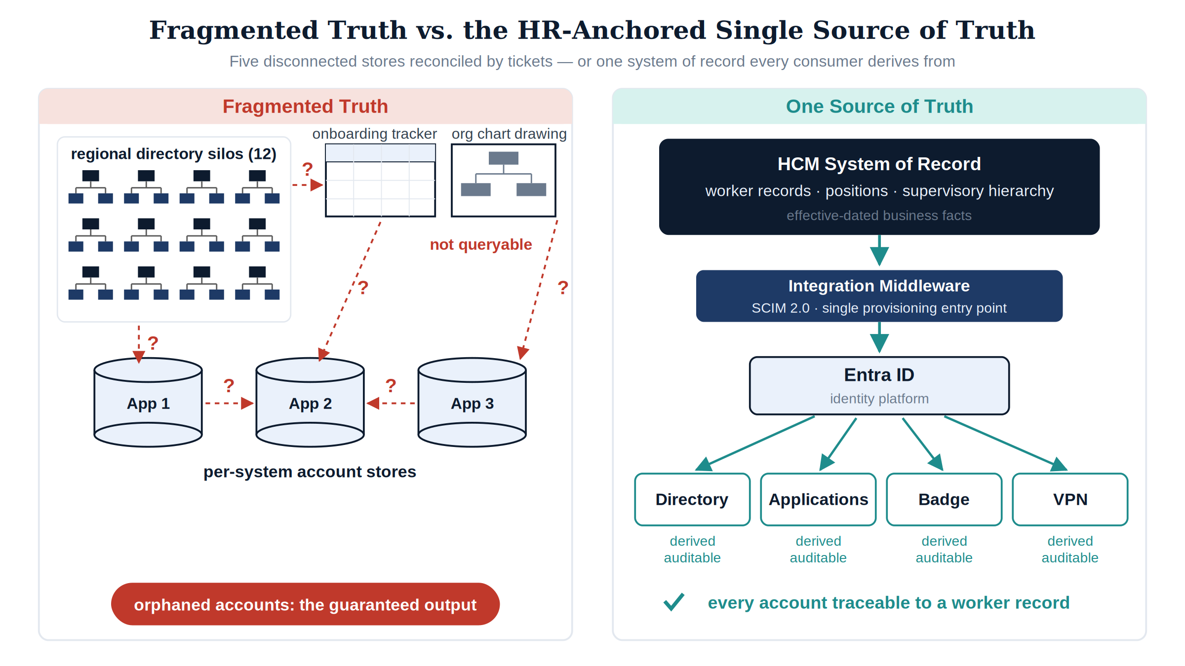
Figure 1: Fragmented identity truth versus the HR-anchored single source of truth

2.4 Why This Cannot Be Patched
Three remediation strategies are regularly proposed to fix fragmented identity truth without designating a source. Each fails for a structural reason, and — as with the authentication patches Book 03 dismantled — naming the reason is what the series’ Closure Necessity doctrine requires:
- “Clean up the directory.” A directory-hygiene project produces a correct snapshot with no event source behind it. Drift resumes the day the project ends, because hires, transfers, and separations keep happening in a system the directory still cannot hear. Cleanup is a measurement, not a source — the identity-plane restatement of the series’ axiom that no scanner creates a source of truth; it can only measure drift from one.
- “Make the directory the master.” Elevating the directory to authority inverts causation. Employment facts would then have to be entered into the directory by administrators — that is, by tickets — which re-creates the ticket queue as the source of truth, now with a grander title and still with no effective dating, no positions, no supervisory hierarchy, and no business authority behind any entry. Nothing that happens inside a directory is a hire or a separation. The directory can hold truth; it cannot originate it.
- “Review our way to correctness.” Quarterly access reviews sample state; they cannot observe transitions. A review that runs ninety days after a separation certifies an orphan for a quarter, and a reviewer confronted with four hundred entitlements approves them in bulk — the rubber-stamp failure mode every assessor recognizes. Reviews are AC-2(j)’s verification layer and this architecture keeps them (sharper — see the organizational SSOT below); but a detective control needs a truth to detect drift from, and reviews cannot manufacture the truth they check against.
Every patch preserves the premise — that identity truth can be maintained where it is consumed rather than where it originates — and the premise is the defect. The remediation is not a cleaner copy; it is a designated origin with an event feed.

3. HRIT as the System of Record

3.1 What a Human Capital System Actually Owns
The human capital platform — HRIT, in federal shorthand; the deployed instance in this architecture is Oracle HCM Cloud, delivered SaaS from the externally managed OCI tenancy that Book 01 placed as the fourth landing-zone environment — is not “the payroll system” any more than the DDI platform of Book 01 is “the DHCP server.” It is the system where four categories of fact are created rather than copied:
The four record families the system of record owns
Record | What It Asserts | Why It Cannot Originate Anywhere Else
Worker record | A person exists as a worker: identifier, legal name, worker type (employee, contractor, intern), employment status | Hiring is an HR business act; the record is created by the act, not in response to it
Position | A seat exists in the organization with a title, grade, and organizational placement — independent of any incumbent | Positions are established and abolished by organizational authority; a vacancy is a real, recorded state
Assignment | A worker holds a position, in an organization, at a location, under a supervisor, effective on a date | The assignment is the employment relationship; every downstream access decision is a projection of it
Supervisory hierarchy | Who reports to whom — the reporting line from any worker to the head of the agency | Reporting relationships are established by the same business acts that create assignments; the directory’s manager field is at best a copy

3.2 The Division of Labor: System of Record Versus Identity Provider
Naming the HCM as the identity SSOT invites a predictable misreading — that it competes with the identity platform. It does not, and the boundary between them is worth stating precisely, because each is authoritative for a different category of fact:
The division of labor between the system of record and the identity platform
Function | System of Record (HCM) | Identity Platform (Entra ID)
Who a worker is — existence, status, type | Authoritative | Derived: account state follows the record
Where a worker sits — position, org, supervisor | Authoritative | Derived: attributes stamped, memberships computed
How identity is proven — credentials, MFA, device binding | — | Authoritative (Book 03’s plane)
Whether a request is permitted now — conditional access, sessions | — | Authoritative (policy enforcement)
Token issuance and claims format | — | Authoritative; claim values trace upstream
The HCM never authenticates a user to an application; the identity platform never decides whether someone is employed. The pipeline in this book is the seam between them, and the direction of authority across that seam never reverses: the HCM asserts facts about people and structure; the identity platform asserts facts about credentials and sessions and derives everything else. The two-authority model is the same truth-plane discipline the series applied between DDI and the certificate estate in Books 01 and 03 — different planes own different verbs, and no plane edits another’s nouns.

3.3 Effective Dating: Truth With a Timeline
The property that separates a system of record from a directory is effective dating. An HCM record does not say “Jane is in the Program Integrity division”; it says “Jane’s assignment to Program Integrity is effective 2026-08-03, superseding her prior assignment, which ended 2026-08-02.” Future-dated hires, transfers, and separations exist in the system before they are true, with the date on which they become true.
This is not a bookkeeping nicety — it is what makes proactive automation possible. Day-one readiness (account, licenses, and group memberships waiting when a new hire badges in) requires knowing the hire before the start date. Same-day revocation requires knowing the separation on its effective date, not when the paperwork finishes circulating. A directory records state; the system of record records state transitions with timestamps, which is exactly the shape an event-driven lifecycle consumes.

3.4 Authoritative Versus Derived Attributes
The discipline that makes the SSOT operable is a written, governed answer to one question per attribute: which plane owns this? An attribute is authoritative where it is created by a business act, and derived everywhere else. Derived attributes are computed, stamped, and read — never edited in place.
The attribute authority map — which plane owns which fact
Attribute | Authoritative Plane | Derived Consumers
Worker identifier (employeeId) | HR system of record — the immutable correlation anchor, assigned at first affiliation | Directory correlation key, audit joins, per-system account linkage
Legal name, worker type, employment status | HR system of record | Display name, account enable/disable state, guest-versus-member classification
Position, title, grade | HR system of record | Role-eligible access packages, approval routing
Organizational placement (department, org code, cost center) | HR system of record | Dynamic group membership, ABAC attributes, chargeback
Supervisor / reporting line | HR system of record | manager attribute, access-package approval routing, attestation campaigns
Duty location | HR system of record | Conditional access named-location context, E911 records (Part 6)
User principal name, mail, group memberships | Identity platform — derived from HR attributes by rule | Applications, token claims
Device identity, names, addresses, certificates | Naming and addressing plane (Books 01–03) | NAC admission, workload identity, TLS
Credential strength, token claims format | Identity plane, cryptographic half (Book 03) | Policy enforcement plane
The map has one rule with no exceptions: corrections flow upstream. When a token carries a wrong department, the fix is a correction to the HR record (or to the derivation rule) — never a hand-edit of the directory attribute, because a hand-edited projection is a new fragment, and fragments are the disease this part cures.
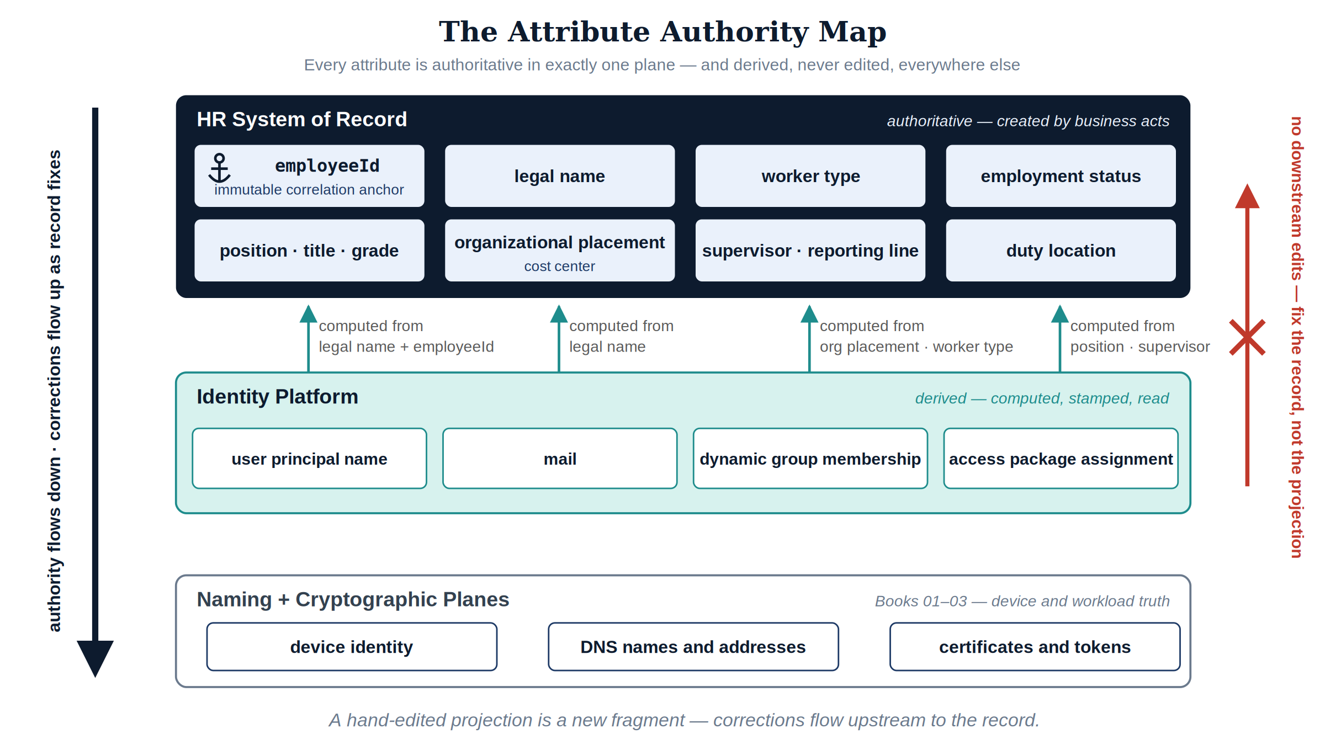
Figure 2: The attribute authority map — each identity attribute and the plane that owns it

4. The Identity SSOT

4.1 The Lifecycle Is an Event Stream
Joiner, mover, leaver — plus the two transitions estates forget until they hurt, rehire and conversion (contractor to employee) — are the five state transitions a worker record undergoes. Each is recorded in the HR system as an effective-dated event, and each maps to a deterministic set of identity actions:
The five lifecycle events and their derived identity actions
HR Event | Recorded Fact | Identity Actions Derived From It
Joiner | Future-dated hire: worker record + assignment created | Account created ahead of start date, disabled until effective date; licenses and baseline group memberships derived from assignment attributes; credential enrollment (Book 02 device, Book 03 authenticator) queued for day one
Mover | Assignment change: new position, organization, location, or supervisor | Attributes re-stamped; dynamic memberships re-computed — old division’s access leaves as the new division’s arrives; access review triggered on the residual (PS-5); approval routing follows the new supervisor of record
Leaver | Effective-dated separation | On the effective date: account disabled, sessions and refresh tokens revoked, group memberships removed, credentials revoked through the Book 03 lifecycle, mailbox and data handled per retention policy — as one automated sequence with one timestamped evidence trail (PS-4)
Rehire | Returning worker matched to prior worker record | Prior identifier re-linked — the person resumes their identity rather than acquiring a second one (IA-4)
Conversion | Worker type changes; affiliation continuous | Same identifier, re-derived access; the contractor-to-employee seam stops minting duplicate identities
The load-bearing property is the direction of causation. Nobody requests an account for a new hire; the hire causes the account. Nobody remembers to disable a leaver; the separation record is the disablement, with an effective date the automation honors to the day. The ticket queue survives only for exceptions — and every exception is visible as a deviation from a computed baseline, which is what makes the exceptions auditable.
Consider the two architectures side by side in the completed series, in the paired-scenario form Book 02 used for the port:
Scenario A — separation under fragmented truth. A worker separates on a Friday. Their FIDO2 key, machine certificate, and enrolled device are all valid — Books 02 and 03 built them well, and nothing about the separation touches any of them. Conditional access evaluates a compliant device and a phishing-resistant credential and correctly allows. Every control fires correctly, because every control is asserting exactly what its plane knows — and no plane knows the one fact that matters. The strength of the substrate now works for the former worker.
Scenario B — separation under the identity SSOT. The same Friday, the effective-dated record initiates the leaver sequence: the account disables, sessions and refresh tokens revoke, memberships drop, the certificate revokes through the Book 03 lifecycle, and the device’s admission credential dies with it — so Monday’s port authentication fails at the wire per Book 02. Each step leaves a timestamp. The substrate’s strength now works for the agency, because the truth plane finally told it the truth.
The pair is the whole book in miniature: Parts 1–3 determine how forcefully the architecture asserts identity; this part determines whether what it asserts is still true.
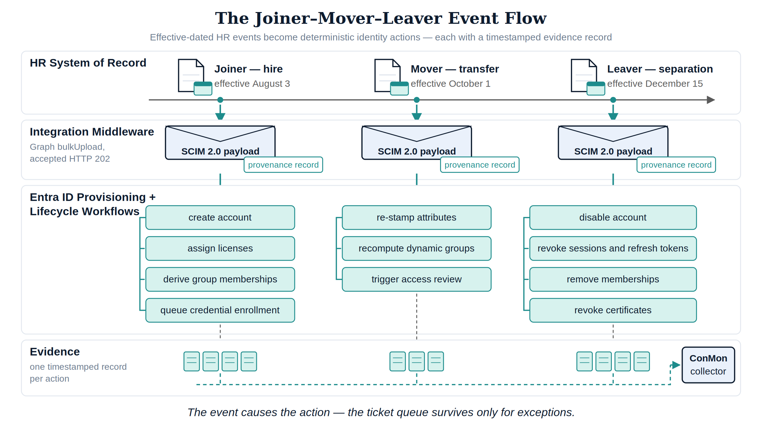
Figure 3: The joiner-mover-leaver event flow from HR record to identity action

4.2 HR-Driven Provisioning Into the Identity Plane
The pipeline that carries events from the system of record into the identity platform is specified canonically in Spec2-D3.1 — API-Driven Inbound Provisioning Architecture (UIAO_136 Spec 2, HR-Agnostic Provisioning Architecture; status Final v1.0, verified against Microsoft Learn). Its shape:
HR system of record → integration middleware → Microsoft Graph bulkUpload API → Entra ID provisioning service — SCIM 2.0 (RFC 7643/7644) as the wire format, submitted over HTTPS, accepted asynchronously with HTTP 202, processed in near real time.
Three properties of this design are doctrine, not implementation detail:
- The architecture is source-agnostic; the deployed source is a configuration. The middleware normalizes any HCM’s export into the canonical SCIM payload, so the bulkUpload call is identical regardless of HR source. Oracle HCM Cloud is the deployed system of record in this architecture — named here the way the series names InfoBlox and Entra ID — but nothing in the design depends on it. If the source ever changes, the adapter changes; the doctrine, the pipeline, and every downstream derivation do not. That is what “HR-agnostic” buys: the SSOT is a role, filled by whichever system holds business authority.
- One entry point, therefore one provenance stream. All inbound identity writes flow through the single provisioning surface, and the middleware emits a provenance record per provisioning event before the Graph call returns. One entry point is what makes lineage (SI-12) and drift detection tractable — there is exactly one door to instrument.
- The envelope is engineered, not assumed. The verified operating numbers: throttling at 40 API calls per 5-second window; tenant daily caps of 2,000 calls per 24 hours (Entra ID P1/P2) or 6,000 (Entra ID Governance); batch payloads of up to 50 operations per call; Entra ID P1 as the licensing floor; and, where on-premises AD writeback persists during directory coexistence, three active provisioning agents for high availability. Worth one sentence of series doctrine: the spec’s own correction history records that its first draft overstated the throttling envelope five-fold and was corrected on verification against the authoritative source — which is precisely the falsifiability discipline this series demands of every load-bearing number.
Native HR connectors, where they exist for a given HCM, are permitted as accelerators — but the API-driven path is the canonical architecture, because it is the one that works for any source and the only one whose middleware layer can compute organizational attributes and emit provenance before the identity platform ever sees the record.

4.3 One Person, One Identifier
IA-4 requires managing identifiers by receiving authorization to assign them, selecting and assigning them to the intended entity, and preventing their reuse for a defined period. The enterprise discipline this architecture implements is stricter and simpler: one person, one identifier, for the life of the affiliation — across every account, system, rehire, and conversion.
The employeeId assigned at first affiliation is the immutable correlation anchor. It never changes with name, position, region, or worker type; every account in every system that belongs to the person carries it; and when the person returns after a break in service, the rehire event re-links the same identifier rather than minting a fresh identity. This is only possible where the person — not the account — is the tracked entity. A directory cannot do it: directories track accounts, and an account deleted at separation takes its history with it. The worker record persists across affiliations, which is why identifier non-reuse and rehire correlation are properties of the HR plane, projected downward.
The same anchor is what makes audit joins possible at all: the token event in the SIEM, the database login, the badge swipe, and the personnel action resolve to one person only because one identifier threads them.

4.4 The Worker-Type Boundary
One authoritative attribute deserves special notice because entire policy families hang from it: worker type. Employee, contractor, intern, volunteer — the classification determines member-versus-guest treatment in the tenant, license assignment, access ceilings, and which conditional-access baseline applies. When worker type is a directory field someone sets at account creation, it is wrong exactly as often as staffing paperwork is ambiguous, and the errors are invisible because nothing reconciles them. When it is derived from the worker record, the contractor whose engagement ends loses access on the engagement’s end date (a leaver event for a non-employee), and the conversion seam — contractor on Friday, employee on Monday — is a re-derivation on the same identifier rather than a second identity with a second, forgotten first account. IA-4(4)’s status characterization (identifying each individual as, for example, a contractor) falls out of the same attribute for free: the characteristic is asserted by the system that classifies workers as a business act, not annotated by an administrator who heard about it.

4.5 Deprovisioning Is an HR Event, Not a Ticket
The leaver sequence deserves its own statement, because it is where the fragmented-truth architecture kills its audit findings — and occasionally its incident reports. In the target state, separation processing is initiated by the effective-dated termination record, and the automated sequence executes on that date, in order, as one workflow:
- Disable the account — the sign-in gate closes first.
- Revoke active sessions and refresh tokens — disabling prevents new tokens; revocation ends the ones already issued, so the control takes effect in token-lifetime minutes rather than at next sign-in.
- Verify — read back the revocation state; a step that cannot be confirmed is a step that did not happen, as far as evidence is concerned.
- Remove group memberships and access-package assignments — entitlements end even where a downstream application caches identity.
- Revoke credentials — certificates through the Book 03 lifecycle; the device’s admission credential through the Book 02 pipeline, so the port stops trusting the hardware too.
- Disposition data — mailbox archive or conversion, file ownership transfer, retention and litigation-hold exceptions applied per policy rather than per memory.
Each step emits a timestamped evidence record; the distance between the HR effective date and the last revocation timestamp becomes a measured, reportable ConMon metric instead of an unknowable. Emergency terminations take a defined manual entry into the same sequence — the trigger is human, the execution and the evidence are identical.
Contrast the input signals available to any alternative mechanism. The network cannot see a termination — the leaver’s laptop authenticates on their last day exactly as it did the day before. The SIEM sees absence of activity, which is indistinguishable from leave. The quarterly access review discovers the account up to ninety days late. Only one system in the enterprise records the separation as a first-class fact with an effective date — and once it does, everything downstream is a subscription.

4.6 The Measured Lifecycle
An event-driven lifecycle is also, incidentally but not accidentally, a measured one — every event-to-action interval is a number, and the numbers are the slot-01 evidence stream:
The lifecycle metrics the event-driven architecture makes measurable
Metric | Definition | What It Evidences
Separation-to-revocation interval | HR effective date/time → last revocation timestamp in the leaver sequence | PS-4’s disable-within-time-period, continuously
Transfer-to-review interval | Transfer effective date → residual-access review completion | PS-5’s initiate-within-time-period
Joiner readiness rate | Share of new hires whose account, licenses, and baseline access exist at start-of-day one | AC-2 lifecycle automation working in the creation direction
Correlation coverage | Share of enabled accounts resolvable to a current worker record | The orphan population, as a query instead of a hunt
Derivation purity | Share of group memberships computed by rule versus assigned by hand | How much of the estate still runs on fragments
None of these numbers exists in a ticket-driven estate — not because nobody computes them, but because the events they measure are not recorded as events. The metric is the argument: an architecture that cannot measure its own revocation latency is asserting PS-4 compliance on faith.

5. The Organizational SSOT

5.1 Structure as Queryable Truth
The second half of this book’s title is the one estates habitually skip. Identity SSOT projects say “HR drives accounts” and stop — leaving organizational truth (who reports to whom, which positions exist, which cost center pays) in the OU paths and the Visio files. The result is an identity plane that knows who exists but not where they sit, which forces every access decision back onto hand-maintained groups — and hand-maintained groups are per-system account stores wearing a nicer name.
The organizational SSOT makes three record families queryable:
- Supervisory organization. The reporting hierarchy as effective-dated records: any worker’s chain of command, resolvable by API at decision time. This is the fact that access-package approvals, attestation campaigns, and separation-of-duties checks all silently depend on — and today mostly fake with a stale directory manager field.
- Position management. Positions as records independent of incumbents. Access eligibility attaches to the position (“this seat is entitled to the case-processing system”), so a vacancy holds no access, an incumbent inherits the seat’s baseline on assignment, and a mover sheds it on reassignment — automatically, because the assignment is the membership rule’s input.
- Cost centers. The financial dimension of placement, driving license chargeback and scoping the blast radius of any entitlement to the organizational unit that owns it.
Book 05’s history explains why this matters at reorganization time. Under fragmented truth, a reorganization is a migration project: OU restructuring, group renames, GPO re-links, months of drift. Under the organizational SSOT, a reorganization is a data change — the HR records change, the attributes re-stamp, the memberships recompute — and the doctrinal corollary follows: a drifted OU estate is overlaid and retired, not remediated. Rebuilding OU trees to match reality is expensive, high-risk, and pointless once no policy reads OU position; the truth is stamped as attributes, policy re-bases onto attribute-driven groups, and the residual OU bindings are inventoried and decommissioned deliberately.

5.2 From HR Attributes to Access: The Derivation Chain
The organizational SSOT earns its keep through one repeatable chain:
Worker record → stamped attributes → dynamic groups → entitlements.
Dynamic groups are membership rules over HR-derived attributes (“all workers whose org code is under X and worker type is employee”), evaluated continuously by the identity platform. Access packages bundle entitlements behind eligibility rules and approval flows that route to the supervisor of record. Conditional access and application roles consume the same attributes as ABAC inputs, and role assignments — RBAC — are granted through the packages rather than by direct assignment. The properties that follow:
- Nobody joins these groups; membership is computed. There is no group owner to lobby, no ticket to lose, no offboarding step to forget. The mover’s access converges on the new assignment’s derivation within the provisioning cycle.
- Every entitlement has a because. Access exists because an attribute satisfied a rule; the attribute exists because an HR record asserted it; the record has an author, a date, and a business act behind it. That chain is the access authorization data AC-2 wants, and it is queryable end to end.
- ABAC and RBAC stop being rival religions. Roles define what a position may touch; attributes prove which position the person holds. Both resolve against the same upstream truth, which is the only arrangement in which they cannot disagree.

5.3 Attestation Lands on the Same Rail
The access reviews this book declined to accept as a source of truth return here as a sharpened verification of it. Once entitlements derive from the organizational SSOT, AC-2(j)’s periodic review stops being a spreadsheet mailed to whoever a stale directory field names, and becomes a campaign the org SSOT itself scopes and routes:
- The reviewer is the supervisor of record — resolved from the reporting hierarchy at campaign launch, not from a manager field last edited during a previous administration.
- The review population is attribute-scoped — “all workers in this organization with access outside its derivation baseline” is a query, so reviewers see the exceptions rather than four hundred rubber-stampable rows.
- The review outcome is a record correction — a rejected entitlement is removed by fixing the attribute, the rule, or the exception entry that produced it, so the same wrong answer cannot regrow from the same wrong input.
The separation-of-duties checks of later parts read the same rails: conflicting-role detection needs to know that two roles are held by the same person (the IA-4 anchor) and whether an approver reports to the requester (the supervisory org). Both facts are queries against this book’s records; neither is answerable from a directory that tracks accounts and drawings that track boxes.
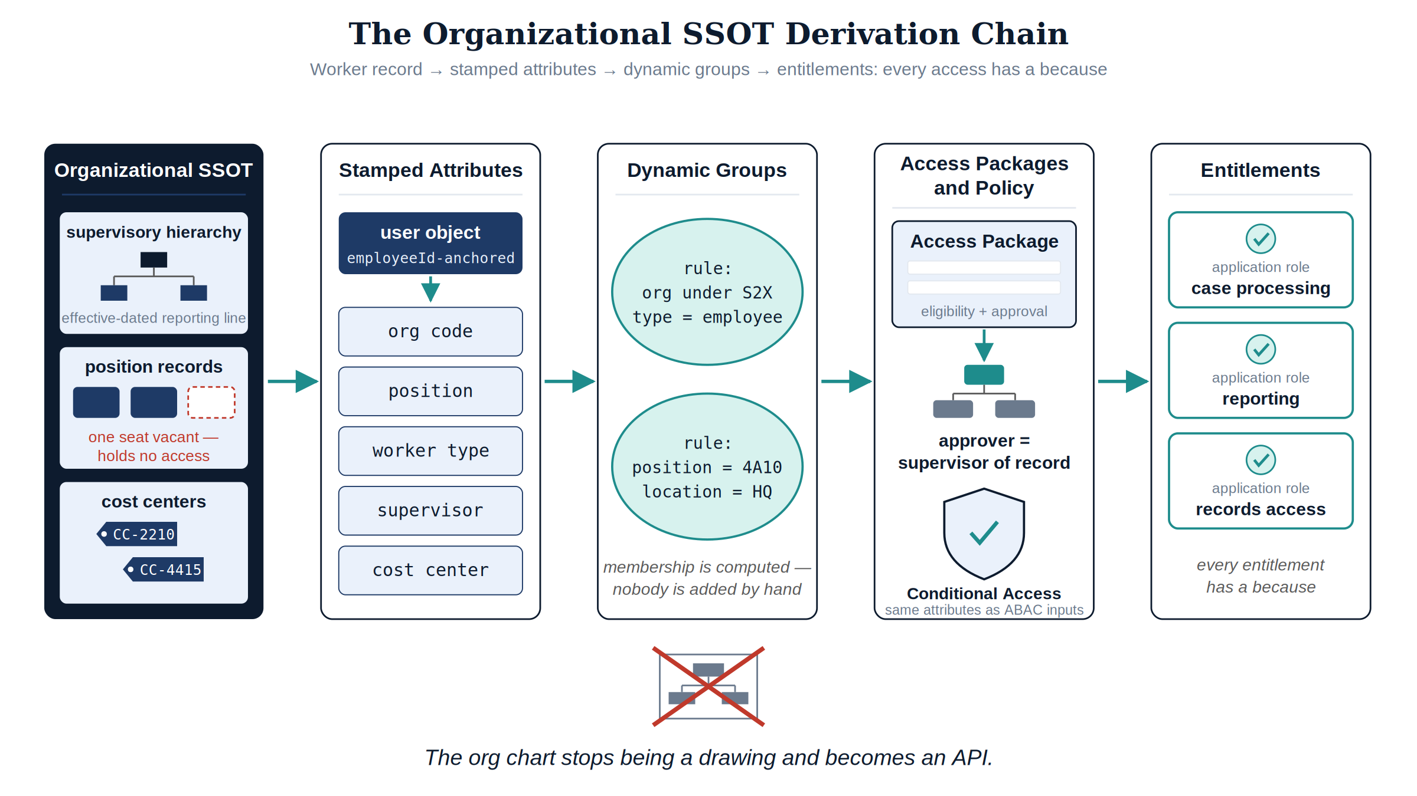
Figure 4: The organizational SSOT derivation chain from HR record to entitlement

6. A SaaS Integration Surface Is an Identity-Plane Surface
The system of record in this architecture is SaaS-delivered from a tenancy the agency does not operate, under an external authorization boundary (Book 01 placed it as the fourth landing-zone environment; Book 03 already observed that the externally managed tenancy has no domain controller and never will). For an estate whose integration reflexes were formed by IaaS and on-premises systems, this looks like a constraint. Examined against the Functional Plane Model, it is the opposite: every surface a SaaS system of record exposes is a function of the truth planes the substrate parts already govern.
The SaaS integration surface decomposed into functional planes
Integration Function | SaaS System of Record | IaaS / VM-Centric System | Functional Plane
Sign-in | Federation — SAML/OIDC assertion from the agency identity provider; trust anchored in exchanged signing keys | OS-level credentials, domain join, local accounts | Identity plane (Book 03’s tokens, verbatim)
Data flow out (workers, org) | SCIM 2.0 / REST extract into the provisioning pipeline over outbound HTTPS | Agents installed on hosts; file drops on shares; database links | Identity plane (this book’s pipeline)
Reachability | DNS resolution of the tenancy’s published service names — through the validating resolvers of Book 01 | Routes, peering, firewall rules, network adjacency | Naming and addressing plane
Evidence | API export of audit and provenance records into the ConMon pipeline | Log agents, collectors, syslog adjacency | Evidence and telemetry plane
Patch/operate | The provider’s obligation inside its own authorization boundary | The agency’s obligation, host by host | — (the boundary is the point)
The structural contrast is what matters. An IaaS integration couples through the enforcement planes — network adjacency, host agents, OS credentials — so every integration widens the attack surface the enforcement planes must then police. The SaaS system of record couples through the truth planes: it is reached by name, trusted by federation, integrated by provisioning protocol, and audited by evidence export, over outbound HTTPS and nothing else. There is no network path to segment, no host to patch inside the agency boundary, no stored OS credential to rotate. The coupling is thin precisely where couplings are dangerous — which is why an externally authorized tenancy can hold the enterprise’s most authoritative records and still leave the agency’s own boundary smaller than before, and why no organizational diagram is needed to reason about it: the plane model, not an org chart, states which function talks to which.
Two consequences follow. First, the substrate parts are literally the integration prerequisites: the federation trust is a Book 03 token relationship; the provisioning pipeline authenticates with a Book 03 workload credential; the tenancy’s endpoints resolve through Book 01’s validating resolvers; and the DNS names those endpoints use are exactly the class of external dependency the naming plane’s egress policies already govern. An agency that built Parts 1–3 has already built everything this integration touches. Second, the pattern generalizes: every future SaaS adoption should be evaluated on the same four surfaces — how it federates, how it provisions, how it resolves, how it exports evidence — and a candidate that demands enforcement-plane coupling (a site-to-site tunnel, an installed agent inside the boundary, a shared OS credential) is asking to be treated as infrastructure, with infrastructure’s obligations. The system of record is the template, not the exception.

6.1 What This Sets Up
This is the hinge from substrate to application. Every later part consumes this book’s truth in a specific, checkable way — none of them can substitute for it, and several silently presume it:
Downstream consumers of the identity and organizational SSOT
Downstream Part | What It Consumes From This Book
Part 5 — network and identity modernization | The authoritative HR-derived identity model that Principle 1 restores against twelve regional silos; the overlay-not-remediate doctrine for the drifted OU estate
Part 7 — SQL authentication modernization | Database access derived from HR-driven dynamic groups, so the DBA ticket queue and the orphaned SQL login end together
Book 10 — privileged access management | Eligibility for privileged roles scoped by position and worker type; JIT activation approvals routed by the supervisory org; the leaver sequence as the floor under every standing privilege
Book 13 — SIEM / detection | The employeeId join key that threads token events, host logs, and personnel context into one investigable person; separation events as detection context (activity from a separated worker’s identity is a first-class alert, not an anomaly score)
Part 17 — PII processing | The HR data flows this book creates are themselves governed PII flows; the provenance stream doubles as the processing record
Book 19 — authorization package | The measured-lifecycle metrics as continuous AC-2/PS-4/PS-5 evidence, packaged through slot-01

 Warning
The honest caveat, stated once and governing everything: designating an authoritative source does not make it correct — it makes its errors authoritative. A drifted HR feed produces a drifted SSOT with excellent lineage. That is why Phase 1 below is source-data remediation rather than integration, why Phase 2 runs in shadow mode until every difference is explained, and why the data-quality obligation lands on the record’s owner rather than on the pipeline. The series’ rule that no scanner creates a source of truth has a corollary: no pipeline launders one.

7. Phased Implementation
The sequencing principle is inherited from Book 03 and sharpened: designate truth, prove the pipe, automate the lifecycle, then derive access. Each phase’s gate is the next phase’s precondition; the ordering is not optional, because deriving access from attributes nobody has agreed to trust is how fragmented truth gets rebuilt with better tooling. One honest caveat governs the whole program: the authoritative source must be correct, not merely designated — a drifted HR feed produces a drifted SSOT, so data-quality remediation is Phase 1 work, not a someday.

7.1 Phase 1 — Attribute Authority Agreement (Weeks 1–6)
Produce the attribute authority map as a governed artifact: every attribute consumed by any access decision, its authoritative plane, its derivation rule if derived, and its data-quality owner. Baseline the HR data against reality for the load-bearing fields (worker type, org placement, supervisor, status) and remediate at the source. Reconcile the existing directory population against worker records: every account matched to an employeeId, or flagged as an orphan candidate with an owner and a deadline.
Gate: the authority map is signed; every enabled account is either correlated to a worker record or on a dated exception list.

7.2 Phase 2 — Inbound Provisioning Pilot (Weeks 7–14)
Stand up the Spec2-D3.1 pipeline — source adapter, middleware normalization and provenance emission, bulkUpload submission — against a pilot population, in shadow mode first: the pipeline computes what it would do, and its output is diffed against the directory’s actual state. Shadow-mode drift reports are the last data-quality net before automation acts. Size the envelope against the verified limits (batching toward 50 operations per call; daily call budget against the tenant cap) and deploy the provisioning-agent tier where AD writeback persists during coexistence.
Gate: thirty days of shadow operation in which every pipeline-versus-directory difference is explained — either a directory error (fixed downstream) or a source error (fixed in HR); provenance records emitted for 100% of events.

7.3 Phase 3 — Lifecycle Automation (Weeks 15–26)
Turn causation on: joiner, mover, and leaver actions execute from HR events, leaver first — revocation is where the risk lives and where the evidence is most valuable. Wire lifecycle workflows to the effective dates; measure the separation-to-revocation interval from day one; route exceptions (emergency terminations, litigation holds) through defined manual paths that end in the same evidence stream. Rehire and conversion matching rules are validated here, against history, before they act.
Gate: separation-to-revocation measured in hours across a full pay-period cycle with zero missed leavers; joiner day-one readiness demonstrated; the account-creation ticket queue retired for covered populations.

7.4 Phase 4 — Organizational-SSOT-Derived Access (Weeks 27–40)
Load the supervisory organization and position records; stamp organizational attributes tenant-wide; convert hand-maintained groups to dynamic membership rules, group by group, with report-only diffs preceding each cutover; re-base access packages so eligibility and approval routing read the org SSOT. Begin the OU-dependency inventory and retire OU-bound policy per the overlay-not-remediate doctrine, in coordination with Part 5’s directory program.
Gate: for covered applications, no direct group-membership assignments remain — every entitlement resolves to a rule, an attribute, and a worker record; a test reorganization (one division renamed and re-parented in HR) propagates to groups and approvals with zero manual directory changes.

7.5 The Program at a Glance
Implementation phases, outputs, and gates
Phase | Output | Gate
1 — Attribute authority agreement | Signed authority map; source data remediated; account-to-worker correlation baseline | Every enabled account correlated or on a dated exception list
2 — Inbound provisioning pilot | Spec2-D3.1 pipeline live in shadow mode; provenance stream; sized throttling envelope | 30 days with every pipeline-versus-directory difference explained
3 — Lifecycle automation | Joiner/mover/leaver executing from HR events; measured intervals; exception paths | Zero missed leavers over a full cycle; hours-scale revocation; creation tickets retired
4 — Org-SSOT-derived access | Attributes stamped; dynamic groups and access packages re-based; OU dependencies retiring | Test reorganization propagates with zero manual directory changes
The sequence deliberately front-loads the unglamorous work. Phases 1 and 2 produce no visible change for end users — which is precisely why estates skip them, automate against unverified data in month one, and spend year two explaining to their assessor why the automation deprovisioned a regional director. Truth first, pipe second, actions third, derivations last.

8. NIST SP 800-53 Rev 5 Control Closure
The table maps each control to its state without the architecture, its state with it, and — per the series’ Closure Necessity doctrine — why no alternate mechanism closes it. Control language follows NIST SP 800-53 Rev 5. One scoping note, stated plainly so the necessity claims stay falsifiable: PS-4 and PS-5 are personnel-security controls. Their procedural elements (exit interviews, property retrieval, the personnel actions themselves) are human obligations no platform performs. What this architecture supplies — and what has no alternate source — is the machine-readable initiating fact and the automation evidence: the timestamped chain from personnel action to access revocation that PS-4(2)’s automated mechanisms and every assessor’s evidence request presume.
NIST SP 800-53 Rev 5 control closure for Part 4 — HRIT and the Identity & Organizational SSOT
Control | Title | Without This Architecture | With This Architecture | Why No Alternative Closes It
AC-2 | Account Management | Accounts created, modified, and disabled by ticket against twelve regional OU trees; access authorizations undocumented or encoded in group names; AC-2(l)’s required alignment with termination and transfer processes exists as a memo; orphaned accounts recur after every sweep | Every account traceable to an authoritative worker record; creation, modification, disablement, and removal executed as consequences of hire, transfer, and separation events; access authorizations resolvable to attribute, rule, and record; alignment with personnel processes is structural because the personnel event is the trigger | AC-2 requires accounts managed in accordance with defined prerequisites and criteria, and requires account management aligned with personnel termination and transfer processes. Alignment presumes a machine-readable personnel truth to align to. Employment facts originate in the HR system as business acts; no scanner, review cadence, or directory hygiene project can generate the fact of employment — they can only copy it, late
AC-2(1) | Automated System Account Management | Either no automation, or automation wired to the directory itself — which automates the propagation of stale truth | Automated mechanisms (inbound provisioning pipeline + lifecycle workflows) support the full account lifecycle, keyed to effective-dated HR events, with provenance per action | The enhancement requires automated mechanisms to support account management. Automation is exactly as correct as its input; the only input that is authoritative for existence, status, and placement of workers is the system of record. Automating from any downstream copy is drift at machine speed — signing broken authorizations efficiently
PS-4 | Personnel Termination | Termination communicated by email and checklist; access disabled days or weeks after the effective date, or never; each system deprovisioned independently; evidence assembled by hand for each audit | The effective-dated separation record initiates the automated sequence — disable, session and token revocation, membership removal, credential revocation — on the effective date, per PS-4(2) automated actions, with a timestamped evidence record per step; the separation-to-revocation interval becomes a measured ConMon metric | PS-4 requires disabling system access within an organization-defined period of termination. The clock starts at an event only the HR system records as a first-class fact — termination is not network-observable, and absence of logins is indistinguishable from leave. Only an event-driven feed from the system that owns the fact can start the automation on time, and only automation produces the within-time-period evidence
PS-5 | Personnel Transfer | Transfers invisible to the identity plane; access accretes across reassignments; the confirmation of ongoing operational need that the control requires has no trigger, so it happens annually or not at all | The mover event triggers re-derivation of access from the new assignment and an access review on the residual, within the organization-defined period of the formal transfer action; old-division access leaves as new-division access arrives | PS-5 requires reviewing and confirming ongoing operational need when individuals are reassigned or transferred, and initiating actions within a defined period after the formal transfer action. The formal transfer action is an HR record; to the network and the directory, the transferred person is the same account on the same laptop. No mechanism that cannot see the transfer can start the required review on time
IA-4 | Identifier Management | Identifiers minted per system; conversions and rehires create duplicate identities; reuse prevention unenforceable because no system remembers identifiers across account deletion; audit joins across systems impossible | One identifier per person, assigned from the worker record at first affiliation, carried by every account, preserved across rehire and conversion; reuse structurally prevented because the worker record — and therefore the identifier’s history — persists after every account is gone; worker type available as the IA-4(4) status characteristic | IA-4 requires authorized assignment, correct binding to the intended individual, and prevention of identifier reuse for a defined period. Non-reuse and rehire correlation require durable memory of persons, not accounts; directories track accounts and forget them at deletion. The only system whose records survive the end of every account — because its subject is the person — is the HR system of record
SI-12 | Information Management and Retention | Identity and organizational data scattered across stores with incompatible schemas and no lineage; the same fact exists in five places with five values; retention unenforceable because ownership is undefined | One designated authoritative source per identity and organizational data type, with documented lineage from HR record through middleware provenance to every downstream consumer; retention applied at the source per applicable requirements; Evidence Act posture demonstrable | SI-12 requires managing and retaining information in accordance with applicable laws, directives, and operational requirements. Lineage cannot be reconstructed afterward from copies — provenance must be emitted where the data originates and flows. Designating and instrumenting one source is the only mechanism that produces lineage rather than asserting it
Closure Necessity — AC-2 from an authoritative source. AC-2 and AC-2(1) close only with automated account management from an authoritative source — and you cannot automate a lifecycle from a source of truth that does not exist. The directory is not that source: it is the object of account management, not the authority for it, and provisioning against twelve drifted regional OU trees automates the drift. Book 00 states the structural dependency for the whole series: tokens work only if the authorization they assert is correct, and a token pipeline atop a broken authorization model signs broken authorizations efficiently. No scanner creates a source of truth; no review cadence generates the fact of employment. The only closure path runs through the system where hire, transfer, and separation are recorded as business acts — which is what makes the HR feed a control mechanism, not an HR convenience.
Closure Necessity — PS-4 same-day revocation. PS-4 requires disabling access within a defined period of termination, and the period is measured from an event that is invisible to every technical sensor the agency owns. No scanner detects that someone left: the leaver’s credentials are valid, their device is enrolled, their token requests are well-formed — on their last day and every day after. The SIEM sees silence, which is what vacation looks like. Exactly one system records the separation as a first-class, effective-dated fact, and only an event-driven feed from that system can start the revocation clock on time. Everything else — tickets, checklists, quarterly reviews — is the same fact arriving late through humans, and the control’s time period does not pause for the mail.
Closure Necessity — IA-4 across affiliations. IA-4’s identifier discipline — one person, one identifier, no reuse — must hold across events that end accounts: separation, rehire, contractor conversion. Any mechanism that tracks accounts loses its memory at exactly the moment the control is tested, because a deleted account takes its identifier history with it. Preventing reuse and re-linking a returning person to their prior identifier require a durable record of the person that persists when every account is gone. The worker record is the only artifact in the enterprise with that lifespan; identifier management is therefore an HR-plane property projected into the directory, and nothing projected can substitute for the projector.
 Note
FedRAMP 20x KSI Alignment — slot-01 identity
In the series’ continuous-monitoring architecture, this book’s evidence binds to the slot-01 identity evidence slot, which carries the KSI-IAM theme rules in the evaluation engine. Under the 19-part restructure, slot-01 — already fed by the cryptographic-identity evidence of Part 3 and the identity-plane parts downstream — additionally binds this book’s lifecycle evidence: the middleware’s per-event provisioning provenance records, lifecycle-workflow execution logs, the measured separation-to-revocation and transfer-to-review intervals, and the account-to-worker-record correlation state that makes orphan detection a query instead of a hunt.
Per the series’ conformance-tooling doctrine (Theme E): configuration baselines can attest that the identity platform’s settings match an intended state; they cannot attest that the accounts in it correspond to people the agency actually employs, in the roles it actually assigned them. That correspondence is authored by the pipeline in this book, and the slot-01 evidence stream is what makes the authored state continuously attestable. The authoritative KSI Closure Necessity Matrix lives in Book 00; Book 19 carries the evidence procedures behind it.

9. Series Context — Part 4 of 19
This part completes the substrate on which the fifteen parts that follow are built:
- Book 01 — the naming and addressing plane: what things are called, where they live, and the DDI source of truth that makes the estate enumerable.
- Book 02 — device identity at the port: what is physically connected, proven at the wire.
- Book 03 — cryptographic identity: how every claim is carried, signed, and verified, path-independently.
- Book 04 (this document) — the human and organizational truth those claims assert: who works here, in what role, under whom, until when — recorded once, derived everywhere.
The substrate in one line per plane: the naming plane knows what exists, the device plane knows what is connected, the cryptographic plane knows the claim is intact, and the HR plane knows the claim is true. Everything after this point is modernization and evidence. Part 5’s identity-modernization program executes Principle 1 against the directory estate using this book’s source; Part 7’s database authentication modernization inherits accounts whose lifecycle this book automates; Book 10’s privileged access assumes the joiner-mover-leaver discipline as its floor; and Book 19 packages the lifecycle evidence this book emits.

9.1 How the Series Doctrine Lands in This Part
For readers tracking the five doctrine themes across the series:
The five doctrine themes as they appear in Part 4
Theme | Its Expression in This Book
A — Closure Necessity | AC-2/AC-2(1), PS-4, PS-5, IA-4, SI-12 each closed (or evidenced) by a mechanism with no alternative: employment facts originate only in the system of record; termination is not network-observable; identifier non-reuse requires memory of persons, not accounts; lineage must be emitted at the origin
B — DIA Fixes Nothing | The same argument one plane up: a faster, flatter network moves authorization decisions everywhere — and thereby makes a wrong authorization available everywhere. Transport modernization raises the price of fragmented truth; it cannot pay it
C — The ADC/Proxy Dissolution | The hand-maintained security group is this book’s dissolving middlebox: a stateful, manually tended artifact that dissolves upward into attribute-driven rules and downward into the HR records that feed them
D — Functional Planes, Not Divisions | The system of record is named as a deployed technology (Oracle HCM Cloud), never as an owner; the SaaS integration section reasons entirely in plane functions — federation, provisioning, resolution, evidence — and needs no organizational chart to do it
E — Conformance Tooling Coverage Gap | Baselines attest settings; they cannot attest that accounts correspond to employed people in assigned roles. That correspondence is authored here and attested continuously through the slot-01 evidence stream
The doctrine in one paragraph: names are authoritative (Book 01), devices prove themselves at the wire (Book 02), every claim travels in a credential mathematics can verify (Book 03) — and this part supplies the one thing mathematics cannot: a true sentence to sign. The token asserts; the worker record is what makes the assertion true. After this part, the series stops building sources of truth, because there are none left to build.

Federal Application-Aware Networking — Part 4 of 19. Parts 1–3 established the naming plane, device identity, and cryptographic identity; Part 4 establishes the human and organizational source of truth they assert. Parts 5–19 apply this four-part substrate to transport, applications, operations, and the authorization package.

